FY 2022
OPERATING BUDGET
DECISION PACKAGE
Requesting Dept: MEA |  |  |  |  |  |  |  |  |  | Division: Harbormaster
Contact Person: Brian W. Taylor, Harbormaster |  |  |  |  |  |  |  |  |  | Dept. Priority: 1 of 5
- Decision Package Title: Harbormaster Certification Training

- Strategic Plan Priority: Education, Public Health and Safety

- Classification | Non-Discretionary (Change in law, utility incr., etc.)  x |  |  |  |  |  |  |  |  |  |  | Discretionary
- Decision Package Request:

Maintain current level of service
x

 |  | Enhanced/Expanded level of service
 |  | Operating Capital
 |  |  |  |  |  | New Item
 |  |  |  |  |  | Replacement
(Describe item, new or replacement, in Detailed Description paragraph below)

- Detailed Description of Request:

Request one time funding of $12,750 for Harbormaster Training to include salary expenses (OT), cost of course, uniforms and cost of books for newly hired Deputy/Harbormaster staff member to attend the Reserve /Intermittent Police Academy.

- If request is involves a position - Attach Employment Requisition form and proposed position description
- If operating capital item - Attach Operating Capital Item Request Listing Form

- Rational/Justification for Request:

Harbormasters have wide and varied responsibilities, ranging from harbor management to enforcing the maritime laws of the state and Town ordinances/rules and regulations. Massachusetts General Law (MGL) requires satisfactory completion of an initial prescribed course of study for harbormasters for anyone who receives an appointment as a Harbormaster or as an Assistant Harbormaster on a full-time basis. The initial training program includes, in part, a component related to law enforcement – specifically the completion of the Massachusetts Police Training Council Reserve Academy. This funding request, if approved, will allow the (new) Deputy Harbormaster/Mooring Officer to complete the required training. Training is mandatory and critical for harbormasters to effectively and lawfully carry out related duties.

- How Efficiency and Effective will this Request be providing this Service? (Explain):

This is not a new service, but one needed to continue to provide the same level of service as in the past.

- Impact on Service if Not Funded (Explain):

If the (new) Deputy Harbormaster/Mooring Officer does not complete the required training, enforcement and duties related to the powers of Harbormaster’s within the Division/State will be severely curtailed and limited in nature and Harbormaster Training Council Certification may not be satisfied per the State of Massachusetts.

- Breakdown of Total Costs By Line Item:

Expense Line Item |  |  | Account Number
Description |  |  | Org Code |  |  |  |  | Object Code |  |  |  |  | Amount
Overtime and Differential Pay |  |  | 018022 |  |  |  |  | 513000 |  |  |  |  | $7000
Training Student Officer Tuition |  |  | 018022 |  |  |  |  | 616050 |  |  |  |  | $4000
Academy Uniforms, Books, etc. |  |  | 015022 |  |  |  |  | 641030 |  |  |  |  | $1750
 |  |  |  |  |  |  |  |  |  |  |  |  | $
 |  |  |  |  |  |  |  |  |  |  |  |  | $
 |  |  |  |  |  |  |  |  |  |  |  |  | $
 |  |  |  |  |  |  |  |  |  |  |  |  | $
 |  |  |  |  |  |  |  |  |  |  |  |  | $
 |  |  |  |  |  |  |  |  |  |  |  |  | $
 |  |  |  |  |  |  |  |  |  |  |  |  | $
 |  |  |  |  |  |  |  |  |  |  |  |  | $
 |  |  |  |  |  |  | Total Expenses |  |  |  |  |  | $12750
- Revenue Offsets: |  |  |  | Yes |  |  |  |  | No  X
Explanation if Yes Above Explain By Describing Funding Sources

Funding Offsets (Fees, Grants, Internal, Budget Line Transfer)
Proposed Funding Source |  |  |  | What is the Price or Lump Sum? |  |  |  |  |  |  | Amount
 |  |  |  |  |  |  |  |  |  |  | $
 |  |  |  |  |  |  |  |  |  |  | $
 |  |  |  |  |  |  |  |  |  |  | $
 |  |  |  |  |  |  |  |  |  |  | $
 |  |  |  |  |  |  | Total Offset |  |  |  | $
 |  |  |  |  | Net Bal. (Expenses – Revenues) |  |  |  |  |  | $
- Further Explanation if Needed:

ATTACHMENT: Please provide any support (including photos) for cost for materials or comparable personnel wages.
https://malegislature.gov/Laws/SessionLaws/Acts/2008/Chapter422
Harbormaster Training Certification Website (link above)

FY 2022
OPERATING BUDGET
DECISION PACKAGE
Requesting Dept: MEA |  |  |  |  |  |  |  |  |  | Division: Harbormaster
Contact Person: Brian W. Taylor, Harbormaster |  |  |  |  |  |  |  |  |  | Dept. Priority: 2 of 5
- Decision Package Title: Harbormaster Operating Expenses

- Strategic Plan Priority: Regulatory Process and Performance, Public Health and Safety

- Classification | Non-Discretionary (Change in law, utility incr., etc.) |  |  |  |  |  |  |  |  |  |  | Discretionary  X
- Decision Package Request:

Maintain current level of service
X

Enhanced/Expanded level of service
X

 |  | Operating Capital
 |  |  |  |  |  | New Item
 |  |  |  |  |  | Replacement
(Describe item, new or replacement, in Detailed Description paragraph below)

- Detailed Description of Request:

Requesting increase in operational expenses to enhance current operations within the Harbormaster Division (Waterways and Moorings Program Operating Expenses) to provide public safety and law enforcement. The requested increase in funding is also needed to maintain two (2) new programs within the Harbormaster Division (Small Vessel Decal, Transient Mooring Program) that were added in the past few years. Additional funding for line items include; Gasoline, Overtime, Boats and Equipment, Maintenance and Vessel Disposal. In FY2021 operating costs were cut due to budget reductions.

- If request is involves a position - Attach Employment Requisition form and proposed position description
- If operating capital item - Attach Operating Capital Item Request Listing Form

- Rational/Justification for Request:

Due to an increase in vessel traffic the Harbormaster Division responded to 489 calls for service (April-Dec). In 2019 the Harbormaster’s calls for service were 133. Calls for service include vessel accidents, medical emergencies, investigations, hazmat response and mitigation, enforcement actions, search and rescue, general services, marine wild life calls and distressed vessel responses.

Public safety on the water is our top priority. In order to enhance operations and to keep up with the increased demand, additional funding is needed. Enhancing operations includes having multiple vessels underway covering 100+ miles of coast line and adjustment to staff shifts to cover peak vessel activity.

An increase in calls for service includes after hour call ins which require additional overtime funding due to contractual obligations.

In 2019, a Small Vessel Decal Program was implemented. In 2020 a Transient Mooring Program was implemented. Additional funding to provide operations to these services is needed. Operations such as disposal of abandoned vessels and oversight and compliance checks of the Transient Moorings.

The Harbormaster Division is responsible for maintaining its fleet of 7 vessels, 2 program vehicles and equipment. Maintenance includes winterizing, oil changes, shrink wrapping, bottom painting, waxing, equipment upgrades/fixes and trailer work.

This Harbormaster Division employs three (3) full time staff and nine (9) seasonal staff. In 2020, a permanent part time employee was reclassified to full time to help with preventative maintenance and operations within the Division.

Due to FY2021 funding and budget restrictions equipment was not able to be replaced, vehicles and vessels were taken out of service, and patrols were minimized in an effort to not exceed available budget.

- How Efficiency and Effective will this Request be providing this Service? (Explain):

Additional funding will support Harbormaster duties throughout the Town of Barnstable.

- Impact on Service if Not Funded (Explain):

Public safety and law enforcement response could be in jeopardized due to vehicles and vessels being taken out of service.

- Breakdown of Total Costs By Line Item:

Expense Line Item |  |  | Account Number
Description |  |  | Org Code |  |  |  |  | Object Code |  |  |  |  | Amount
Gasoline - Waterways |  |  | 018021 |  |  |  |  | 636010 |  |  |  |  | $2000
Salary/Wages-Overtime - Waterways |  |  | 018021 |  |  |  |  | 513000 |  |  |  |  | $2000
Boats and Equipment - Waterways |  |  | 018021 |  |  |  |  | 674020 |  |  |  |  | $2000
Marine Related Services - Moorings |  |  | 018021 |  |  |  |  | 621050 |  |  |  |  | $1500
Gasoline - Moorings |  |  | 018022 |  |  |  |  | 636010 |  |  |  |  | $1000
 |  |  |  |  |  |  |  |  |  |  |  |  | $
 |  |  |  |  |  |  |  |  |  |  |  |  | $
 |  |  |  |  |  |  |  |  |  |  |  |  | $
 |  |  |  |  |  |  |  |  |  |  |  |  | $
 |  |  |  |  |  |  | Total Expenses |  |  |  |  |  | $8500
- Revenue Offsets: |  |  |  | Yes  x |  |  |  |  | No
Explanation if Yes Above Explain By Describing Funding Sources: Funding offsets can include revenue generated from the Small Vessel Decal Program, Transient Mooring Program and Mooring Program Fees.

Funding Offsets (Fees, Grants, Internal, Budget Line Transfer)
Proposed Funding Source |  |  |  | What is the Price or Lump Sum? |  |  |  |  |  |  | Amount
Mooring Fees |  |  |  | 8500 |  |  |  |  |  |  | $8500
 |  |  |  |  |  |  |  |  |  |  | $
 |  |  |  |  |  |  |  |  |  |  | $
 |  |  |  |  |  |  |  |  |  |  | $
 |  |  |  |  |  |  |  |  |  |  | $
 |  |  |  |  |  |  |  |  |  |  | $
 |  |  |  |  |  |  | Total Offset |  |  |  | $8500
 |  |  |  |  | Net Bal. (Expenses – Revenues) |  |  |  |  |  | $0
- Further Explanation if Needed: The mooring program fees, small vessel decal fees and transient mooring fees cover approximately 95% cost of Harbormaster Operations within the Town of Barnstable.

ATTACHMENT: Please provide any support (including photos) for cost for materials or comparable personnel wages.
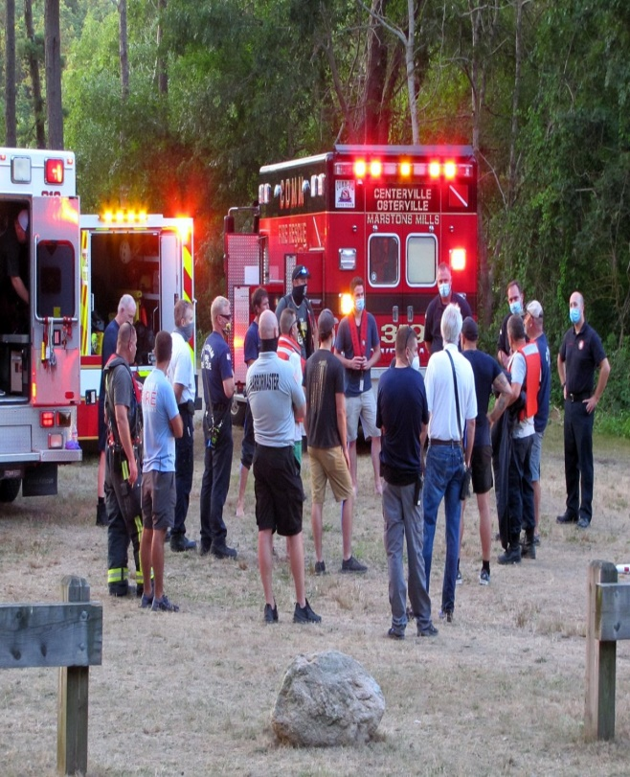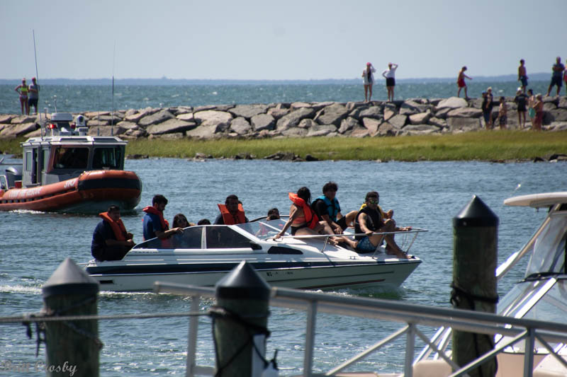
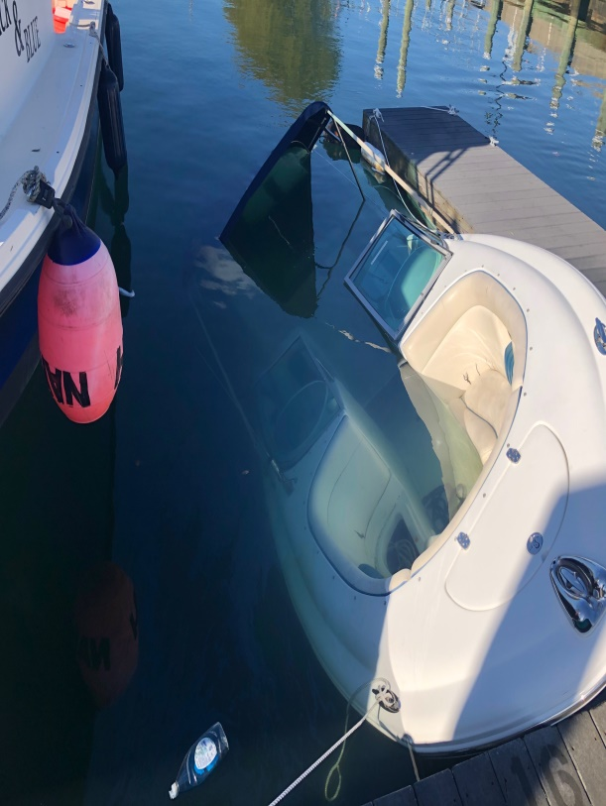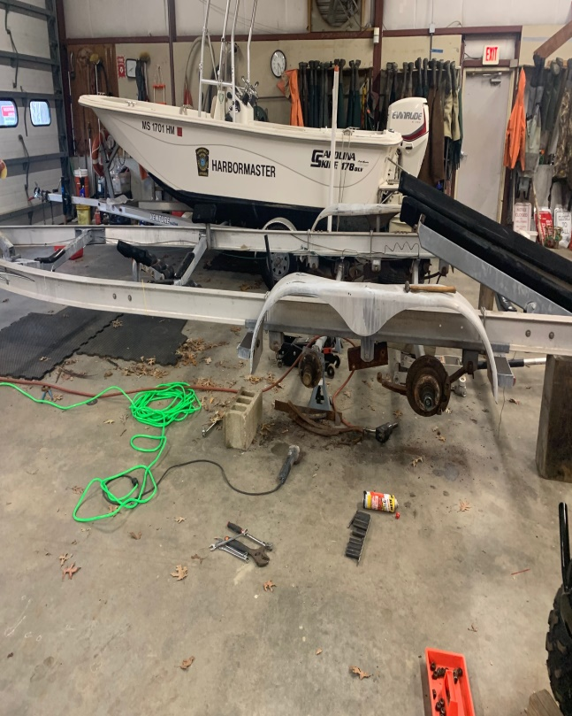

FY 2022
OPERATING BUDGET
DECISION PACKAGE
Requesting Dept: MEA |  |  |  |  |  |  |  |  |  | Division: Harbormaster
Contact Person: Brian W. Taylor, Harbormaster |  |  |  |  |  |  |  |  |  | Dept. Priority: 3 of 5
- Decision Package Title: Vehicles Purchase

- Strategic Plan Priority: Public Health and Safety

- Classification | Non-Discretionary (Change in law, utility incr., etc.) |  |  |  |  |  |  |  |  |  |  | Discretionary  X
- Decision Package Request:

Maintain current level of service
X

 |  | Enhanced/Expanded level of service
Operating Capital
x
New Item
x

 |  |  |  |  |  | Replacement
(Describe item, new or replacement, in Detailed Description paragraph below)

- Detailed Description of Request:

Requesting one time funding to purchase two (2) vehicles for the Harbormaster Division. Request is for purchase of vehicles and outfitting the vehicles with equipment necessary for operation.

- If request is involves a position - Attach Employment Requisition form and proposed position description
- If operating capital item - Attach Operating Capital Item Request Listing Form

- Rational/Justification for Request:

Currently the Harbormaster Division has three (3) full time staff members and one (1) general fund vehicle. Therefore, the Division does not have enough vehicles for the number of staff. Requesting to purchase two (2) general fund vehicles one (1) for the Waterways Program and one (1) for the Mooring Program to assist with Harbormaster duties. One (1) program vehicle if approved will be sold to the Sandy Neck Park Beach Enterprise program. This funding includes outfitting vehicles with the necessary equipment to perform duties such as, winch, lights, radios, back rack, hauler hitch.

The Harbormaster Division oversees marine public safety and law enforcement aspects within the Town of Barnstable. Often, land side response by vehicle is necessary to provide public services. Operations include: enforcement of state/local laws, town bylaws and regulations, towing and hauling vessels/trailers, placing and hauling aids to navigation, response to emergency and non-emergency calls for service, removal of mooring gear and hazards to navigation.

- How Efficiency and Effective will this Request be providing this Service? (Explain):

The purchase of these new vehicles and outfitting for Harbormaster duties will improve efficiency and effectiveness of daily operations. Improving public safety and emergency response.

- Impact on Service if Not Funded (Explain):

Public Safety and Law Enforcement may be compromised.

- Breakdown of Total Costs By Line Item:

Expense Line Item |  |  | Account Number
Description |  |  | Org Code |  |  |  |  | Object Code |  |  |  |  | Amount
Vehicle Truck - Waterways |  |  | 018021 |  |  |  |  | 702020 |  |  |  |  | $38815
Vehicle Truck - Moorings |  |  | 018022 |  |  |  |  | 702020 |  |  |  |  | $38815
Equipment Outfit – Waterways |  |  | 018021 |  |  |  |  | 702020 |  |  |  |  | $10000
Equipment Outfit – Moorings |  |  | 018021 |  |  |  |  | 702020 |  |  |  |  | $10000
 |  |  |  |  |  |  |  |  |  |  |  |  | $
 |  |  |  |  |  |  |  |  |  |  |  |  | $
 |  |  |  |  |  |  |  |  |  |  |  |  | $
 |  |  |  |  |  |  |  |  |  |  |  |  | $
 |  |  |  |  |  |  |  |  |  |  |  |  | $
 |  |  |  |  |  |  |  |  |  |  |  |  | $
 |  |  |  |  |  |  |  |  |  |  |  |  | $
 |  |  |  |  |  |  | Total Expenses |  |  |  |  |  | $97630
- Revenue Offsets: |  |  |  | Yes  x |  |  |  |  | No
Explanation if Yes Above Explain By Describing Funding Sources: Funding offset from the Sandy Neck Park Beach Enterprise program and Waterways Improvement Fund could be used per MGL Part 1 Title VII Chapter 40 Section 5G.

Funding Offsets (Fees, Grants, Internal, Budget Line Transfer)
Proposed Funding Source |  |  |  | What is the Price or Lump Sum? |  |  |  |  |  |  | Amount
Sandy Neck Enterprise |  |  |  | $10,000 |  |  |  |  |  |  | $10000
WWIF |  |  |  | $70,000 |  |  |  |  |  |  | $87630
 |  |  |  |  |  |  |  |  |  |  | $
 |  |  |  |  |  |  | Total Offset |  |  |  | $97630
 |  |  |  |  | Net Bal. (Expenses – Revenues) |  |  |  |  |  | $0
- Further Explanation if Needed:

ATTACHMENT: Please provide any support (including photos) for cost for materials or comparable personnel wages.
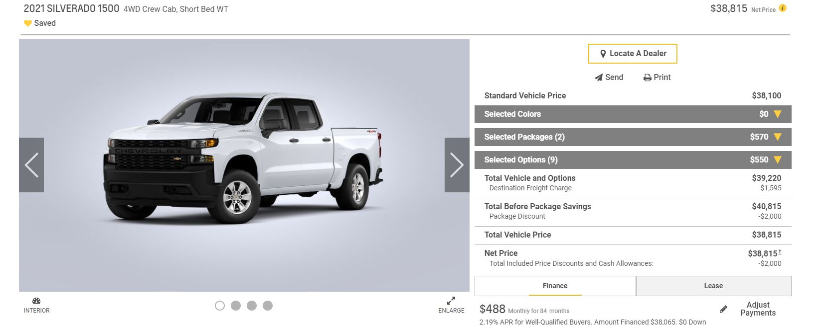
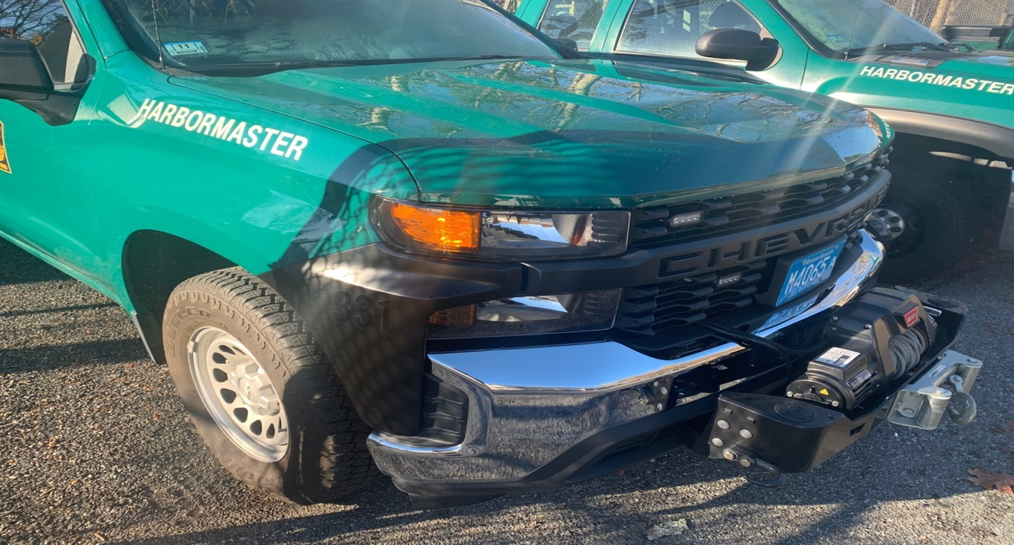Example of outfitted Harbormaster vehicle

FY 2022
OPERATING BUDGET
DECISION PACKAGE
Requesting Dept: MEA |  |  |  |  |  |  |  |  |  | Division: Harbormaster
Contact Person: Brian W. Taylor, Harbormaster |  |  |  |  |  |  |  |  |  | Dept. Priority: 4 of 5
- Decision Package Title: Transient Mooring Program

- Strategic Plan Priority: Economic Development, Public Health and Safety

- Classification | Non-Discretionary (Change in law, utility incr., etc.) |  |  |  |  |  |  |  |  |  |  | Discretionary  x
- Decision Package Request:

 |  | Maintain current level of service
Enhanced/Expanded level of service
x

 |  | Operating Capital
New Item
x

 |  |  |  |  |  | Replacement
(Describe item, new or replacement, in Detailed Description paragraph below)

- Detailed Description of Request:

Request new funding of $7,000 for Transient Mooring Program to include cost of new mooring gear, maintenance of gear and placement/hauling of moorings. $4,000 from this request will be for one time funding to purchase mooring gear (Mushroom Anchors, Chain, Mooring Ball etc). $3,000 for this request will be needed yearly to maintain gear and contract mooring servicers to haul/place.

- If request is involves a position - Attach Employment Requisition form and proposed position description
- If operating capital item - Attach Operating Capital Item Request Listing Form

- Rational/Justification for Request:

New in 2020, the Harbormaster’s Division rolled out a Pilot Transient Mooring program. New funding is needed to operate and enhance this program. This has been supported by the Waterways Committee and Economic Development Task Force. The Harbormaster would like to have the Town of Barnstable on the map as a visiting designation by vessel owners. Increasing the amount of transient moorings and size of the vessels that can tie up to these moorings will positively impact not just our waterways but small business owners and local establishments. It’s also important to note that these moorings are used by our citizens to access the water.

- How Efficiency and Effective will this Request be providing this Service? (Explain):

If funded, this request will allow us to expand the Transit Mooring Program immediately.

- Impact on Service if Not Funded (Explain):

The Transient Mooring program will not have the available funds to be able to grow and add additional moorings for larger size vessels. As a result, individuals visiting the Town of Barnstable by our waterways will not be able to have a location to tie up to.

- Breakdown of Total Costs By Line Item:

Expense Line Item |  |  | Account Number
Description |  |  | Org Code |  |  |  |  | Object Code |  |  |  |  | Amount
Contract Services - Mooring Servicer |  |  | 018022 |  |  |  |  | 615090 |  |  |  |  | $3000
Marine Related Services - Mooring Gear |  |  | 018022 |  |  |  |  | 621050 |  |  |  |  | $4000 (one time request)
 |  |  |  |  |  |  |  |  |  |  |  |  | $
 |  |  |  |  |  |  |  |  |  |  |  |  | $
 |  |  |  |  |  |  |  |  |  |  |  |  | $
 |  |  |  |  |  |  |  |  |  |  |  |  | $
 |  |  |  |  |  |  |  |  |  |  |  |  | $
 |  |  |  |  |  |  |  |  |  |  |  |  | $
 |  |  |  |  |  |  |  |  |  |  |  |  | $
 |  |  |  |  |  |  |  |  |  |  |  |  | $
 |  |  |  |  |  |  |  |  |  |  |  |  | $
 |  |  |  |  |  |  | Total Expenses |  |  |  |  |  | $7000
- Revenue Offsets: |  |  |  | Yes |  |  |  |  | No  X
Explanation if Yes Above Explain By Describing Funding Sources:

Funding Offsets (Fees, Grants, Internal, Budget Line Transfer)
Proposed Funding Source |  |  |  | What is the Price or Lump Sum? |  |  |  |  |  |  | Amount
Mooring Fees |  |  |  | 7000 |  |  |  |  |  |  | $7000
 |  |  |  |  |  |  |  |  |  |  | $
 |  |  |  |  |  |  |  |  |  |  | $
 |  |  |  |  |  |  |  |  |  |  | $
 |  |  |  |  |  |  |  |  |  |  | $
 |  |  |  |  |  |  |  |  |  |  | $
 |  |  |  |  |  |  | Total Offset |  |  |  | $7000
 |  |  |  |  | Net Bal. (Expenses – Revenues) |  |  |  |  |  | $0
- Further Explanation if Needed: The Economic Development Task Force; Waterways Access Subcommittee in the future may be able to help assist with some of these funding offsets associated with the Transient Mooring Program.

ATTACHMENT: Please provide any support (including photos) for cost for materials or comparable personnel wages.
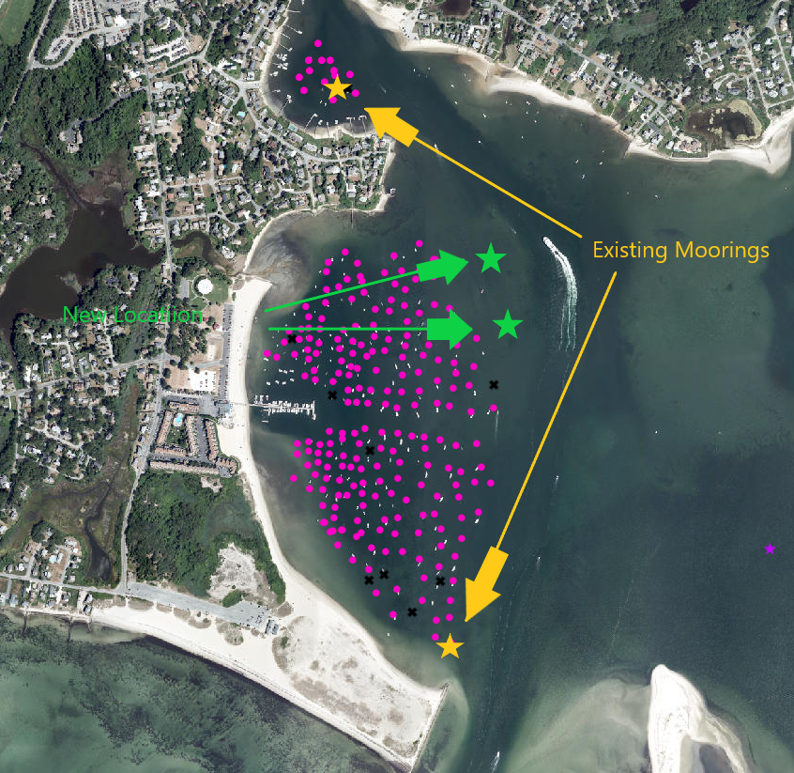

Example Hyannis (Lewis Bay)
FY 2022
OPERATING BUDGET
DECISION PACKAGE
Requesting Dept: MEA |  |  |  |  |  |  |  |  |  | Division: Harbormaster
Contact Person: Brian W. Taylor, Harbormaster |  |  |  |  |  |  |  |  |  | Dept. Priority: 5 of 5
- Decision Package Title: Seasonal Pay Rate Increases

- Strategic Plan Priority:

- Classification | Non-Discretionary (Change in law, utility incr., etc.)  x |  |  |  |  |  |  |  |  |  |  | Discretionary
- Decision Package Request:

Maintain current level of service
x

 |  | Enhanced/Expanded level of service
 |  | Operating Capital
 |  |  |  |  |  | New Item
 |  |  |  |  |  | Replacement
(Describe item, new or replacement, in Detailed Description paragraph below)

- Detailed Description of Request:

Proposal is to fund the mandated increase in the hourly pay rate of Seasonal Harbormaster staff.

Harbormaster positions include; Seasonal Boat Ramp Attendants (4), Seasonal Mooring Officer (1)

- If request is involves a position - Attach Employment Requisition form and proposed position description
- If operating capital item - Attach Operating Capital Item Request Listing Form

- Rational/Justification for Request:

This increase is a town wide increase on seasonal positions.

- How Efficiency and Effective will this Request be providing this Service? (Explain):

This will give the town an opportunity to offer a more competitive pay rate and to be able to keep employees that have experience from past years.

- Impact on Service if Not Funded (Explain):

Harbormaster Division would not have enough money in line item “Temporary Salary and Wages” for personnel costs to fund positions.

- Breakdown of Total Costs By Line Item:

Expense Line Item |  |  | Account Number
Description |  |  | Org Code |  |  |  |  | Object Code |  |  |  |  | Amount
Salary/Wages-Temp Mooring |  |  | 018022 |  |  |  |  | 512000 |  |  |  |  | $3,220
Salary/Wages-Temp Waterways |  |  | 018021 |  |  |  |  | 513000 |  |  |  |  | $3,500
 |  |  |  |  |  |  |  |  |  |  |  |  | $
 |  |  |  |  |  |  |  |  |  |  |  |  | $
 |  |  |  |  |  |  |  |  |  |  |  |  | $
 |  |  |  |  |  |  |  |  |  |  |  |  | $
 |  |  |  |  |  |  |  |  |  |  |  |  | $
 |  |  |  |  |  |  |  |  |  |  |  |  | $
 |  |  |  |  |  |  |  |  |  |  |  |  | $
 |  |  |  |  |  |  |  |  |  |  |  |  | $
 |  |  |  |  |  |  |  |  |  |  |  |  | $
 |  |  |  |  |  |  | Total Expenses |  |  |  |  |  | $6,720
- Revenue Offsets: |  |  |  | Yes  x |  |  |  |  | No
Explanation if Yes Above Explain By Describing Funding Sources: Revenue generated from Harbormaster Revenue Accounts (Mooring Permits, Small Vessel, Transient Moorings).

Funding Offsets (Fees, Grants, Internal, Budget Line Transfer)
Proposed Funding Source |  |  |  | What is the Price or Lump Sum? |  |  |  |  |  |  | Amount
Harbormaster Revenue |  |  |  | $6,720 |  |  |  |  |  |  | $6,720
 |  |  |  |  |  |  |  |  |  |  | $
 |  |  |  |  |  |  |  |  |  |  | $
 |  |  |  |  |  |  |  |  |  |  | $
 |  |  |  |  |  |  |  |  |  |  | $
 |  |  |  |  |  |  |  |  |  |  | $
 |  |  |  |  |  |  | Total Offset |  |  |  | $6,720
 |  |  |  |  | Net Bal. (Expenses – Revenues) |  |  |  |  |  | $0
- Further Explanation if Needed:

Harbormaster Division revenue generated covers approximately 95% of cost of service to run division.

ATTACHMENT: Please provide any support (including photos) for cost for materials or comparable personnel wages.
Harbormaster
Boat/Ramp Attendant |  | 66052 | T690 | $ 15.50 | 39
Seasonal Dockmaster/Asst. Harbormaster |  | 66050 | T764 | $ 17.50 | 47
Seasonal Security Officer/Asst. Harbormaster |  | 66051 | T688 | $ 17.50 | 47
Seasonal Pumpout Operator/Asst. Harbormaster |  | 66053 | T698 | $ 19.25 | 54
Seasonal Mooring Officer, Harbormaster |  | 66054 | T765 | $ 19.25 | 54
Seasonal Security Officer, Harbormaster (new 07) |  | 66055 | T766 | $ 18.50 | 51
Seasonal Waterways Assistant, Harbormaster |  | 66058 | T767 | $ 19.25 | 54
Seasonal Waterways Enforcement Officer |  | 66060 | T719 | $ 19.25 | 54
Seasonal Marina Facilities Maintenance Laborer |  | 66059 | T711 | $ 20.00 | 57
Seasonal Harbor/Ramp Attendant |  | 66057 | T707 | $ 15.50 | 39

